CS7646: Project 8 – Strategy Evaluation

Marcus Anderson  
manderson332@gatech.edu

***Abstract—***In this report, we aimed to compare the performance of a manual strategy and a strategy learner. The manual strategy involves developing trading orders solely based on indicator rules, while the strategy learner pairs a classification-based, reinforcement-based, or optimization-based learner with indicator rules to create trading orders. This report analyzes the effectiveness of the strategies using various metrics, mainly profitability.

**1 INTRODUCTION**

The objective of this project is to compare the performance of a manual strategy and a strategy learner within the financial market. The manual strategy combines a minimum of three out of the five indicators from Project 6, while the strategy learner is based on one of the learners we’ve used before, using those same indicators. The overall approach involves testing both strategies on specific symbol and in-sample/out-of-sample time period, and conducting experiments to evaluate their effectiveness.

This report will describe the manual strategy, the strategy learner, and the experiments conducted to evaluate their respective performance. The results of the analysis will provide a deeper insight into the strengths and weaknesses of each strategy and will utilize visuals such as charts and statistics to showcase this.

**2 INDICATOR OVERVIEW**

The first component of this project was to select three to five technical indicators from Project 6 to utilize in both the manual strategy and strategy leaner. We’ll discuss each indicator in terms of their respective implementation and the parameters that were optimized in both the manual strategy and the strategy learner.

**2.1 %B Indicator (%B)**

The %B indicator is a technical indicator that measures the position of the current price relative to the upper and lower Bollinger Bands. Bollinger Bands (BB) is a technical indicator that’s used to identify the volatility and potential price movements of an asset. The %B indicator is more of a normalized version of the BBs that ranges from 0 to 1, indicating where the current price is relative to the upper and lower bands. The formula for the %B indicator is: **%B = (Price - Lower Band) / (Upper Band - Lower Band)**. This means in order calculate the %B indicator, you must calculate the upper/lower bands from BB.

I chose to optimize the parameters by using all %B values less than 20% to indicate a buy signal, and values over 80% to indicate a sell signal. These were also coupled with a 20 day lookback period to provide optimal results for both the manual strategy and strategy learner.

**2.2 Percentage Price Oscillator (PPO)**

The Percentage Price Oscillator (PPO) is a technical indicator used to measure and represent the difference between two EMAs as a percentage. In order to calculate PPO, we take the difference between the long-term 26-day and short-term 12-day EMAs and divide it by the 26-day EMA, then multiply that result by 100. The formula: **PPO = ((12-day EMA - 26-day EMA) / 26-day EMA) x 100**. The 9-day EMA of the PPO is used to calculate the signal line and finally, the difference between the PPO and the signal line is plotted as a histogram: **PPO Histogram: PPO – Signal Line.**

For the manual strategy and strategy learner, I chose to optimize the parameters by using all PPO histogram values less than -5% to indicate an oversold buy signal, and values over 105% indicating overbought sell signal. These parameters provided optimal PPO histogram results for a 12-day and 26-day short/long term EMA with a 9-day signal line.

**2.3 Moving Average Convergence/Divergence Oscillator (MACD)**

The Moving Average Convergence/Divergence (MACD) is a technical indicator that helps traders follow trends and momentum shifts, triggering potential buy or sell signals. MACD is made up of three line indicators: MACD line, signal line, and MACD histogram.

Similar to PPO, MACD utilizes 12-day and 26-day EMAs to calculate the MACD line, by subtracting the 26-day EMA from the 12-day EMA: **MACD Line: 12-day EMA – 26-day EMA**. The 9-day EMA of the MACD line is used to calculate the signal line and finally, the difference between the MACD line and the signal line is plotted as a histogram: **MACD Histogram: MACD Line – Signal Line**.

To optimize the use of the MACD histogram in the manual strategy and strategy learner, the parameters I chose implement were the comparison of current day’s MACD histogram result with its respective previous day's result. If the current day’s result was greater than the previous day’s result it’d indicate a buy signal, whereas if it was less than the previous day’s result, a sell signal is indicated. These parameters, joined with the same EMA and signal-line days as the PPO histogram provide the most optimal MACD histogram and trade signal results.

**3 MANUAL STRATEGY**

**3.1 Describe**

In order to create an overall signal for trading, I used a strategy that involved implementing the optimal parameters for each of the three indicators that I explained earlier. The three indicators were then combined to create a buy or sell signal for each trading day. The buy signal was represented by a value of 1, the sell signal was -1, and 0 represented no signal.

To determine an overall buy/sell signal for each trading day, I added the three indicator data frames together and calculated the signal sum of each trading day. If the sum was 2 or more, a buy signal was triggered, and if the sum was -2 or less, a sell signal was triggered. These bounds gave me the best overall trading table I could use to find the short/long entry points.

Once I had the trade table, I was able to use it to determine which dates had buy/sell signals. I then put these results into a trading algorithm to identify the "short", "out", or "long" (-1,0,1 respectively) trading days. I used the same algorithm that I built for the Theoretically Optimal Strategy in project 6 as a base. Using this algorithm, helped me to optimally find the best trading days to trigger a short/long entry point. I was able to identify the best entry points at the most opportune trading days, which helped maximize profit for this strategy.

Overall, I believe that this is an effective trading strategy because it takes into account multiple indicators and combines them to create an overall signal. Additionally, by utilizing the Theoretically Optimal Strategy algorithm as a base, I was able to create an effective trading function that optimally identified the best short/long entry points. By using this, more informed trading decisions were made.

**3.2 Compare**

After building the strategy the next step was to analyze and compare the performance of my Manual Strategy against the benchmark for both the in-sample and out-of-sample time periods. The benchmark strategy involves making one $1,000 trade on the first day and holding that position until the last trading day of the time period.

Based on the figures below, we can observe that our Manual Strategy outperformed the benchmark for the majority of the in-sample time period. Figure 1 shows the in-sample results consistently outperformed the benchmark for the majority of the time period. On the other hand, Figure 2 shows that the out-of-sample results performed slightly worse than the benchmark up until September/October 2010. Additionally, by referencing the statistics tables calculated for both time periods, Table 1 and Table 2, we can see that our manual strategy had higher cumulative returns and means, and lower standard deviation amounts, meaning less volatility, compared to the benchmark.

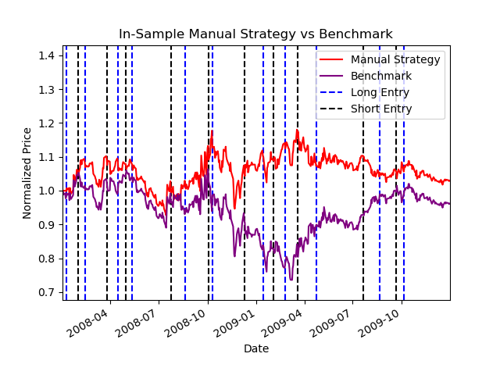

*Figure 1—* *This graph shows the comparison of the manual strategy and benchmark results in regards to JPM prices during an in-sample time period.*

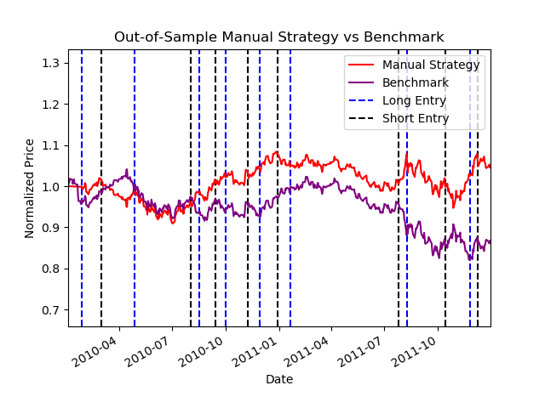

*Figure 2—This graph shows the comparison of the manual strategy and benchmark results in regards to JPM prices during an out-of-sample time period.*

|  |  |  |  |
| --- | --- | --- | --- |
| **Portfolio Type** | **Cumulative return** | **Standard Deviation** | **Mean** |
| Benchmark | -0.037924 | 0.017468 | 7.507884e-05 |
| Manual Strategy | 0.029792 | 0.015251 | 0.000174 |

*Table 1—This table compares the cumulative return, standard deviation, and mean calculations of the manual strategy and benchmark results in regards to JPM prices during an in-sample time period.*

|  |  |  |  |
| --- | --- | --- | --- |
| **Portfolio Type** | **Cumulative return** | **Standard Deviation** | **Mean** |
| Benchmark | -0.133735 | 0.008780 | -0.000246 |
| Manual Strategy | 0.046545 | 0.007999 | 0.000122 |

*Table 2— This table compares the cumulative return, standard deviation, and mean calculations of the manual strategy and benchmark results in regards to JPM prices during an out-of-sample time period.*

**3.3 Evaluate**

The out-of-sample period provides an important test of the performance of the manual strategy, as it allows performance evaluation on new and unseen data. As mentioned earlier, the manual strategy performed slightly worse than the benchmark up until September/October 2010 during the out-of-sample period. There could be several reasons for the cause of the underperformance during this period. One possible reason could be overfitting during the in-sample time period, which we can see occurs around March/April 2008 in Figure 1 right at the beginning. The algorithm used for this strategy performs well using historical data. So using a whole new time period, a whole year in between the in-sample and out-of-sample time periods to be exact, may cause some variation. Even though the out-of-sample results did not have a strong start, it still out performed the benchmark results overall.

**4 STRATEGY LEARNER**

**4.1 Describe**

To frame the trading problem as a learning problem for my Random Forest Learner, Random Tree Learner (RTLearner) coupled with the BagLearner, I used the following steps.

First, I used the same three indicators (%B, PPO, and MACD) as in the manual strategy. However, instead of returning training signals, I simply returned the raw results from these indicators. Using the raw results, I generated three new data frames, which were used as the train/test x data for my learner. To generate the train y data, I utilized a classification trader algorithm that used JPM prices to calculate YBUY and YSELL values determined by a lookback period, N day returns, and a y-threshold value. The lookback period was set to 19, since the window size used for the %B calculation was set at 20 days, meaning index 19 was the first trading day that had price data. I made the N-day value set to 10 which played a part in calculating the return price of the respective JPM price per trading day. Lastly, the y-threshold was calculated by multiplying the inputted impact value by 2, which is then compared with the return price to determine if the y-value will be a YBUY (1) or a YSELL (-1).

Once the evidence was collected, I tested the data by querying the test x data and using those predicted results to indicate buy/sell signals. If the trading day result was greater than 0.5, it was a buy signal, if lower than -0.5, it was a sell signal. I then used these signals to build a trade order table and applied those trade orders into the same algorithm used in the manual strategy.

**4.2 Data Adjustment**

I focused on adjusting the parameters of my strategy learner in order to optimize its performance. Specifically, I adjusted the leaf size, bag size, and the y-threshold calculation to obtain results that beat out both the manual strategy and benchmark performances.

While I kept the leaf size and bag size at their “default” values of 5 and 20 respectively, I did need to tweak the y-threshold calculation in order to obtain the desired results. The y-threshold is responsible for determining the outcome of the train y data used in the add evidence portion of the strategy learner. By adjusting this parameter to 2 times the impact input value, I was able to obtain better performance results overall.

**5 EXPERIMENT 1**

**5.1 Describe**

In this experiment, the initial hypothesis was that the strategy learner would outperform both the manual strategy and benchmark, as the strategy learner is an AI classification-based algorithm. To test this hypothesis, I set up a trading simulator using JPM prices for the in-sample date ranges.

First, I obtained the trade orders calculated for both my manual strategy and the strategy learner. Then, I put the respective trade orders in the trading simulator with a starting value of $100,000, commission of $9.95, and impact value of 0.005. The trading simulator returned the portfolio data frame for both respective strategies. I then calculated the normalized prices for the portfolio values: **portval/portval.iloc[0]**, to use for chart comparisons.

Similar to the manual strategy versus benchmark experiment mentioned earlier, for the benchmark values, I made a trade order table of just one $1,000 trade on the first day, and held that position throughout the time period. I calculated the portfolio values with the same parameters, and normalized the results for comparison.

Finally, I repeated the same process for the out-of-sample time period. This allowed me to compare the performance of the manual strategy, strategy learner, and benchmark for both the in-sample and out-of-sample time periods.

**5.2 Evaluate**

Based on the charts shown below, Figure 3 (in-sample) and Figure 4 (out-of-sample), it appears that the classification-based learner outperforms both the manual strategy and benchmark results for both the in-sample and out-of-sample time periods. My initial hypothesis of the classification-based learner outperforming the other strategies is supported by this data. Looking at the charts, we can see that the lookback period of 19 has a small impact at the beginning of the strategy learner data line. However, shortly after, the normalized price begins to increase significantly.

It is possible to expect this relative result every time with in-sample data since we have access to the data used for sampling. This allows me to refine my strategies based on the historical data and adjust them accordingly. However, the out-of-sample data may not always perform as well as the in-sample data because it represents new, unseen data, and it may behave differently based on the sample data.

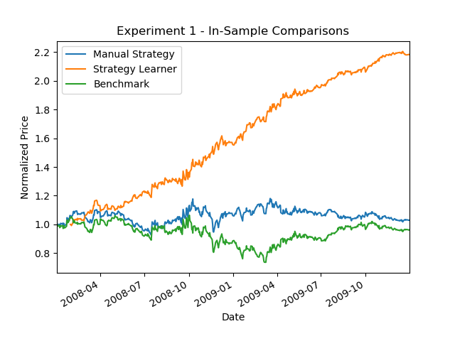

*Figure 3— This graph shows the comparison of the manual strategy, strategy learner, and benchmark results in regards to JPM prices during an in-sample time period.*

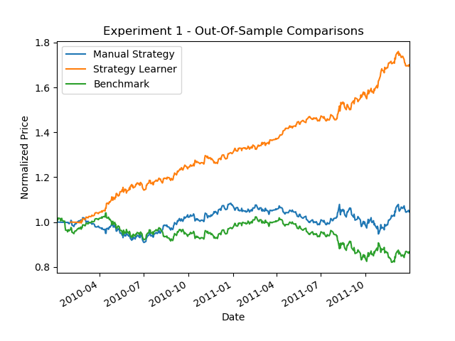

*Figure 4— This graph shows the comparison of the manual strategy, strategy learner, and benchmark results in regards to JPM prices during an out-of-sample time period.*

**6 EXPERIMENT 2**

The impact value is an important parameter in trading simulation as it affects the transaction costs and the y-threshold used in the add evidence step. Based on this, my initial hypothesis that increasing the impact value will have a negative impact on the performance of the strategy learner. This is because higher impact values will lead to higher transaction costs and more aggressive trading, which may not be optimal for the strategy learner.

To test this hypothesis, I selected five impact values: 0.00, 0.002, 0.05, 0.7, and 1.00, and assessed the impact of these values on two metrics: average daily returns and number of trades made. Based on the average daily returns shown in Figure 5, it seems that my initial hypothesis may have been incorrect. This chart shows that the average return actually increased as the impact value got higher. This may be because higher impact values allow the strategy learner to take more aggressive trading actions, thus leading to higher returns, the opposite of what I hypothesized originally. In regards to the number of trades made, Figure 6 shows that 0.05 returned the highest number of trades, while 1.00 returned the lowest. Though, this may not be a bad thing since 1.00 yielded the highest average daily returns.

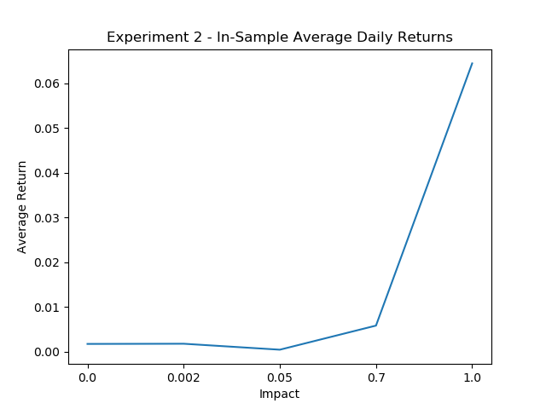

*Figure 5— This graph shows the comparison of how different impacts affect the average daily returns calculated using the strategy learner during an in-sample time period.*

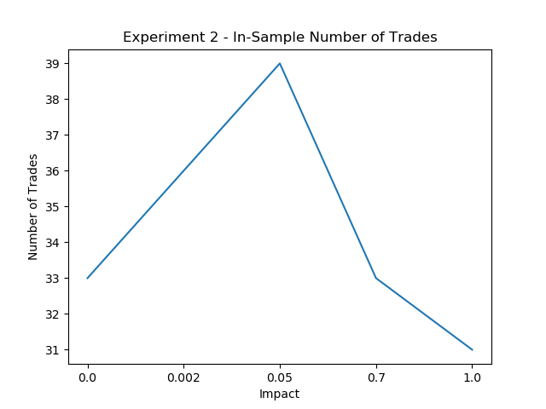

*Figure 6— This graph shows the comparison of how different impacts affect the number of trades calculated using the strategy learner during an in-sample time period.*

**7 CONCLUSION**

In conclusion, this project aimed to compare the performance of a manual strategy and a strategy learner in the financial market using a specific set of indicators. The manual strategy involved combining at least three of the five indicators, while the strategy learner was based on the Random Forest learner using the same indicators. The experiments conducted evaluated the effectiveness of each strategy during in-sample and out-of-sample time periods and on specific symbols. I hope readers gained substantial knowledge by analyzing the results that were presented with the help of charts and statistics to gain a deeper insight into the strengths and weaknesses of each strategy.

**8 REFERENCES**

1. Dolan, B. (2022, December 19). MACD indicator explained, with formula, examples, and limitations. Investopedia. <https://www.investopedia.com/terms/m/macd.asp>
2. Mitchell, C. (2022, December 13). Percentage price oscillator (PPO): Definition and how it's used. Investopedia. <https://www.investopedia.com/terms/p/ppo.asp>
3. StockChart.com. (n.d.). %B indicator. %B Indicator [ChartSchool]. <https://school.stockcharts.com/doku.php?id=technical_indicators%3Abollinger_band_perce>
4. StockCharts.com. (n.d.). Bollinger bands. Bollinger Bands [ChartSchool]. <https://school.stockcharts.com/doku.php?id=technical_indicators%3Abollinger_bands>
5. StockCharts.com. (n.d.). MACD (moving average convergence/divergence oscillator). MACD (Moving Average Convergence/Divergence Oscillator) [ChartSchool]. <https://school.stockcharts.com/doku.php?id=technical_indicators%3Amoving_average_convergence_divergence_macd>
6. StockCharts.com. (n.d.). Percentage price oscillator. Percentage Price Oscillator [ChartSchool]. <https://school.stockcharts.com/doku.php?id=technical_indicators%3Aprice_oscillators_ppo>